DREAM ADVICE: TED MILLS SOLO ART EXHIBITION
March 7 through April 2, 2013
OPENING NIGHT RECEPTION: 8 p.m. - midnight, Thursday, March 7
Elsie’s Tavern, 117 W. De La Guerra, Santa Barbara. (805) 963-4503

In his first solo show, Santa Barbara artist/filmmaker/writer Ted Mills presents a handpicked selection of his original “inspirational” postcards, words of advice brought to him from the bowels of his subconscious.

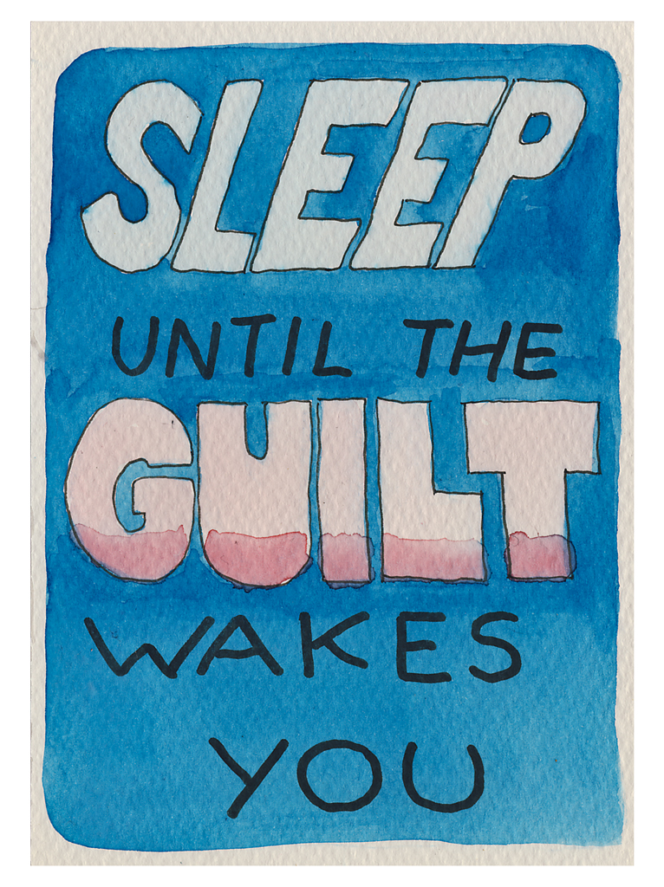
“These isn’t your typical ‘Follow a Rainbow’ advice,” says the artist. “But for the last year I’ve had dreams where very important but unknown people approach me and impart advice. In the dream these sage words made perfect sense. Later, after waking and writing them down, they are more baffling than helpful. Hence, the need to enshrine them in crudely scrawled and painted postcards. I live with the belief that one day they will suddenly make sense.”

Last summer Mills co-curated the multimedia “Standard Deviation” art show in the heart of Fiesta. He has also curated video shows at Contemporary Arts Forum.

All works are original watercolor on 4x6 in. postcards and signed on reverse.
Price list available.

Ted Mills is available for interviews at tedmills@gmail.com or 805-895-4897
Some art can be seen at tedmillsart.tumblr.com

